Small-Business

Car Dealership

Database Management Systems

MGIS-320

Manlu Liu

Jonathan Abood, Kate Ferguson, Bryan Gascon,

Mitchell Haagensen, Franck Panou

**Table of Contents**

Executive Summary……………………………………………………………………………….2

Project Scenario…………………………………………………………………………………...2

Problems of Current System…………………………………………………………….………...2

Assumptions…………………………………………………………………………………...…..3

ER Diagram …………………………………………………………………………….………...3

Tables…….…………………………………………………………………………….………….4

Queries….……………………………………………………………………………...………….6

Forms….……………………………………………………………………………….………….9

Reports….…………………………………………………………………………….………….11

What We Learned….…………………………………………………………………..…...……13

**Executive Summary**

This is a report based on a small car dealership business looking to make a database which helps them to be more organized and provide a better experience for their customers. Some of the big issues they face include keeping track of inventory and location of the inventory. We created an Access database with some sample data put into a multitude of tables such as Car, SalesPerson, Dealership, Customer, Mechanic, and Work Order. We then created Queries which help with the dealership to recognize some more statistical data about inventory, demographic tracking, and purchase and repair history using queries like: Best Seller Cars, Cars by Make, Sales by Location, and Salesperson performance. We then created some forms which allow the salespersons of the dealership to fill out a form as a sales invoice, thereby producing a receipt for the customer and tracking the information within the system; as well as a form for mechanics to track the work orders being done. Lastly we then included some preliminary reports that would be useful for quick access like: Cars by Make, Used Cars, New Cars, and Sold Cars. This is definitely a database made for tracking at a small business, but in the future it could become more user friendly and have more reports added to make it even more useful for a larger enterprise with a multitude of locations.

**Project Scenario**

We are a small-business type car dealership, who currently has a location in Buffalo and Rochester. We wanted a system that would track both our inventory of cars available for purchase, and also the purchase history of our customers to start building a localized demographical data on our customers. We also wanted a system that would keep customer records in tact that could be tracked to when a work order needed to be done. Additionally we needed a system that tracked the sales being made by each salesperson and the work being done by each mechanic. We were hoping that a system like this would help us keep track of our inventory and customers better to provide a quicker and more organized experience when customers wanted to know what vehicles were available, work done on vehicles and overall purchase history.

**Problems of Current System**

Currently, the car dealerships’ databases are redundant and both salespeople and car buyers aren’t able to look up inventory at another dealership; i.e. if someone is at the Rochester dealership they can’t see what the Buffalo dealership. This makes it inconvenient on the consumer end because they don’t want to make a trip to a dealership if they don’t know which dealership has the car they’re looking for. Also, when purchasing a car, most buyers like to know if there has been service or work done to it before buying it. For the salespeople, when helping people they may not know exactly what is in inventory at smaller dealerships. On the management side, it is helpful to know inventory and work being done at both dealerships by looking at a single database. Not only that, but keeping paper records becomes very redundant and it is hard to search effectively.

**Assumptions**

* A car can only be associated with one dealership.
* A car can have multiple work orders, but a work order can only be associated with one car.
* A salesperson can only be associated with one dealership.
* A sales invoice can include only one salesperson.

**ER Diagram**

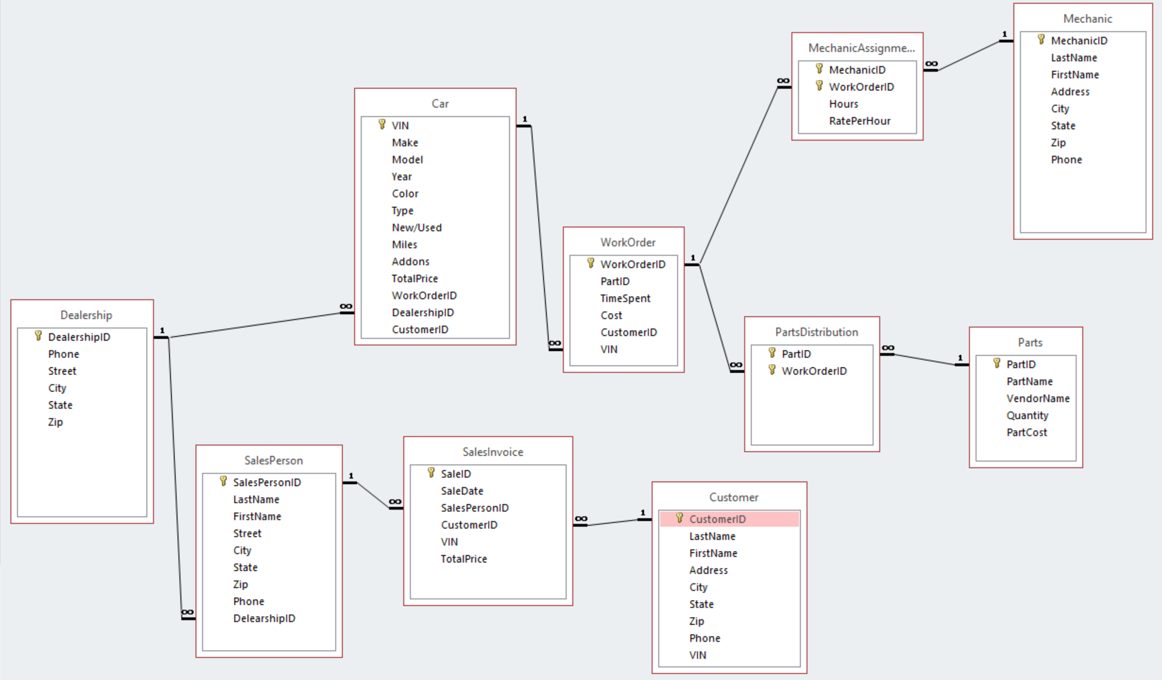

* A Dealership has many cars, and a car is associated with one dealership.
* A SalesPerson is associated with one dealership, and a dealership has many SalesPersons.
* **Bridge Table:** SalesInvoice connects the many to many relationship of the customer and the salesperson. A salesperson can have nay sales, and a customer can have many purchases.
* A car can have many work orders but a work order can only be associated with one car.
* **Bridge Table:** PartsDistribution, connects the many to many relationship of parts and work orders. A work order can have many parts, and parts can be on many work orders.
* **Bridge Table:** MechanicAssignment, connects the many to many relationship of work orders and mechanics. A work order can have many mechanics and a mechanic can be associated with many work orders.

**Tables**

**Car:** VIN, Make, Model, Year, Color, Type, New/Used, Miles, Addons, Total Price, WorkOrderID, DealershipID, CustomerID



Provides summary of features of the cars and its history (i.e. miles) that are important to both car buyers and the dealership, as well as if any work has been done to it.

**Customer:** CustomerID, LastName, FirstName, Address, City, State, Zip, Phone

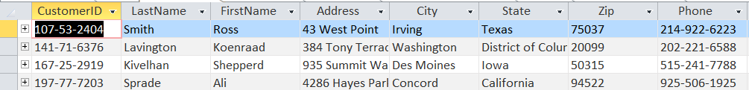

Provides contact information and ID for customers

**Dealership:** DealershipID, Phone, Street, City, State, Zip



Provides basic location and phone number for dealerships in the database

**Mechanic Assignments**: MechanicID, WorkOrderID, Hours, RatePerHour

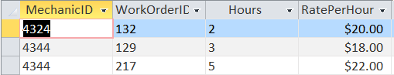

Bridge table to assign mechanics to work order and track time spent

**Mechanic**: MechanicID, LastName, FirstName, Address, City, State, Zip, Phone

Provides basic information for each mechanic

**Parts**: PartID, PartName, VendorName, Quantity, PartCost

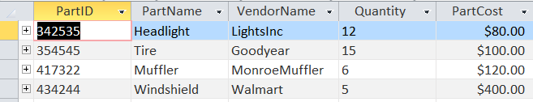

List of parts, current inventory and cost

**Parts Distribution:** PartID, WorkOrderID

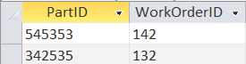

Bridge table to track which parts go to each work order

**Sales Invoice**: SaleID, SaleDate, SalesPersonID, CustomerID, VIN, TotalPrice

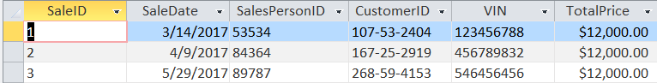

Provides sales ID and information for sales completed

**Salesperson**: SalesPersonID, LastName, FirstName, Street, City, State, Zip, Phone, DealershipID



Provides salesperson ID and information for each salesperson

**Switchboard Item**s: SwitchboardID, ItemNumber, ItemText, Command, Argument

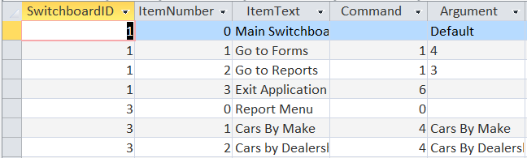

Contains information used by/needed for the switchboard

**Work Order**: WorkOrderID, PartID, TimeSpent, Cost, CustomerID, VIN

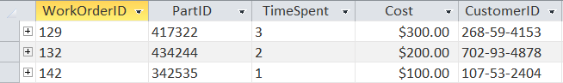

Provides details for work order, including time and cost.

**Queries**

**Automatic Cars**

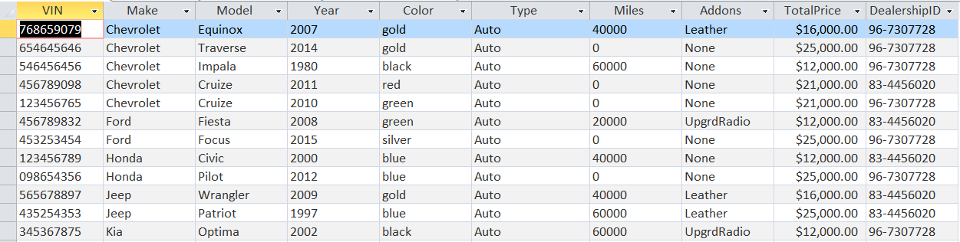

Lists all cars in the database with automatic transmissions.

**Best Sellers**

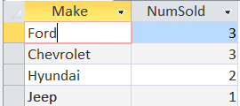

Lists car makes and the amount sold in a descending order so management can easily identify which brands are selling the most.

**Buffalo Dealership**

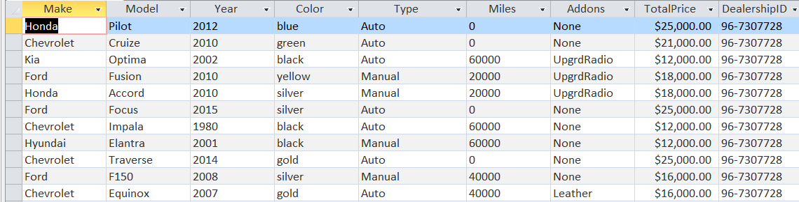

Lists cars in inventory at the Buffalo dealership.

**Cars with Work Done**

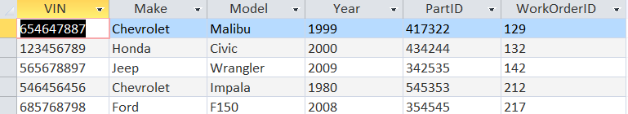

Lists all cars in inventory that have had work done. Helpful because customers want to know how the car has been altered/what work has been done to a car before purchasing it.

**Current Inventory**

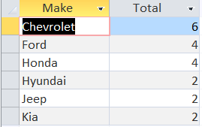

Shows current inventory grouped by make. Helps both salesperson and customer to know what is in inventory.

**Manual Cars**

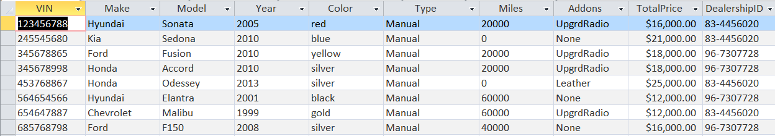

Lists all cars in the database with manual transmissions.

**New Cars**

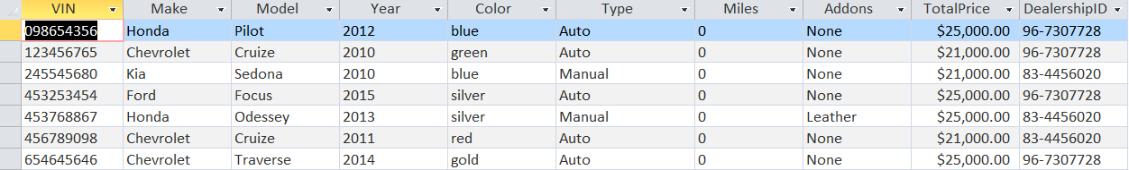

Lists all cars that are new. Especially helpful for customers who are looking specifically for a new car.

**Rochester Dealership**

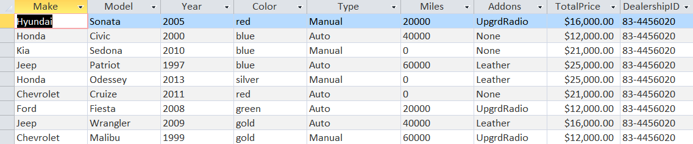

Lists cars in inventory at the Buffalo dealership.

**Salesperson Performance**

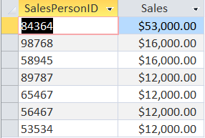

Shows which salesperson has had the most sales.

**Sold Cars**

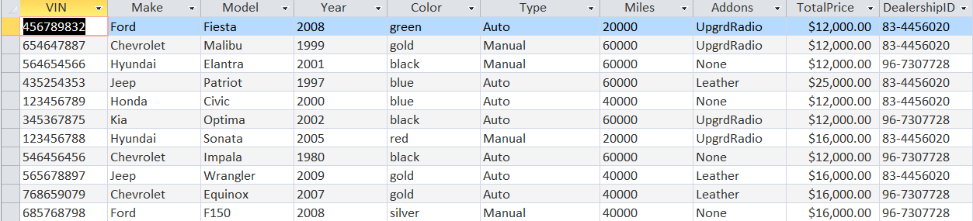

Lists all cars sold to date.

**Used Cars**

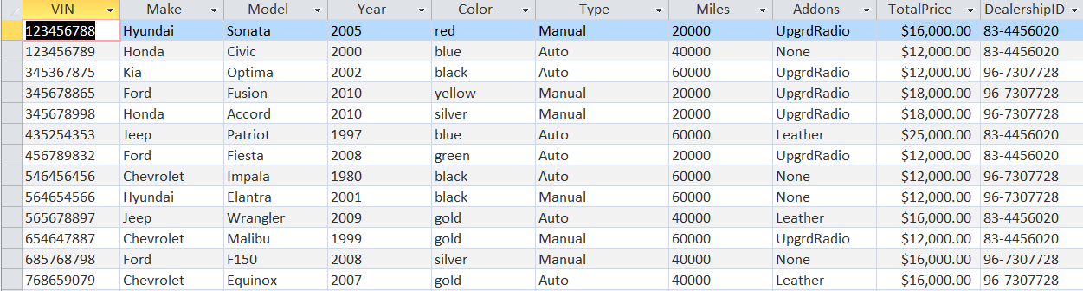

Lists all cars that are new. Especially helpful for customers who are looking specifically for a new car.

**Work Order**

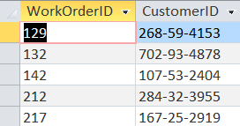

Lists all work orders and customer it was completed for.

**Forms**

**Car Subform**

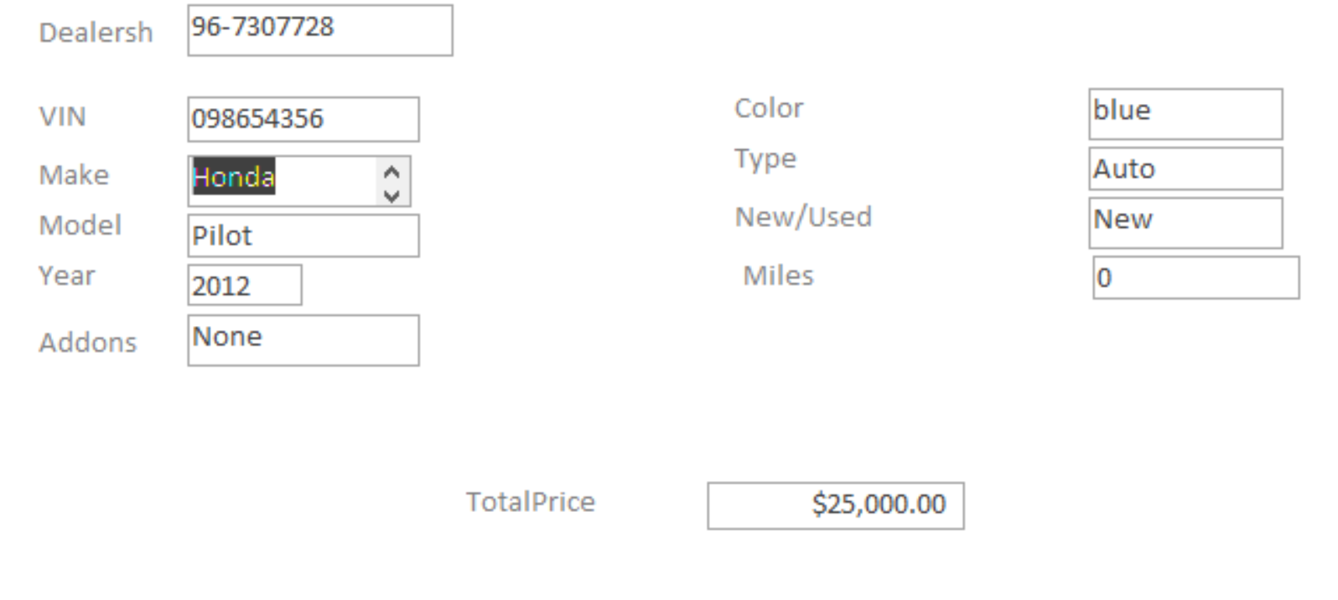

Allows cars, and all attributes and dealership, to be entered into inventory.

**Sales Form**

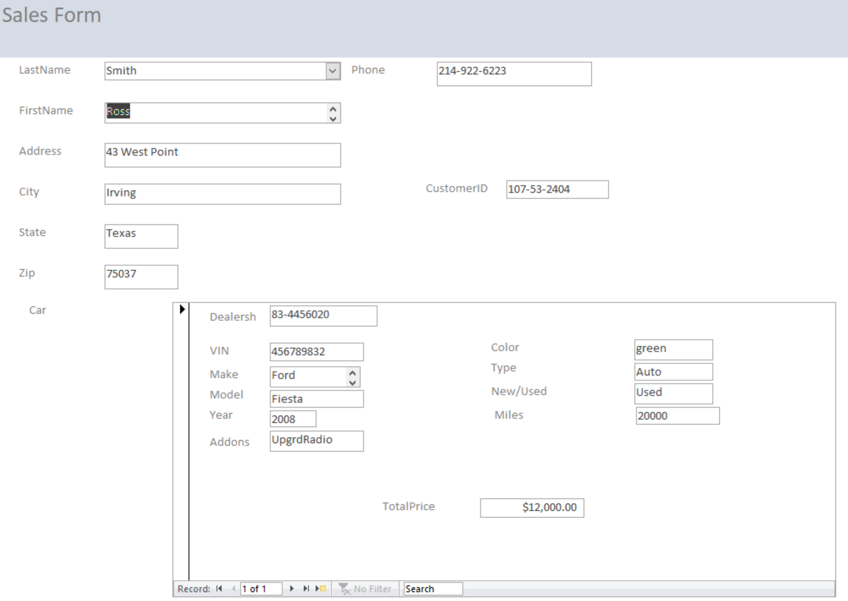

Enters sales into the database and updates inventory.

**Switchboard**

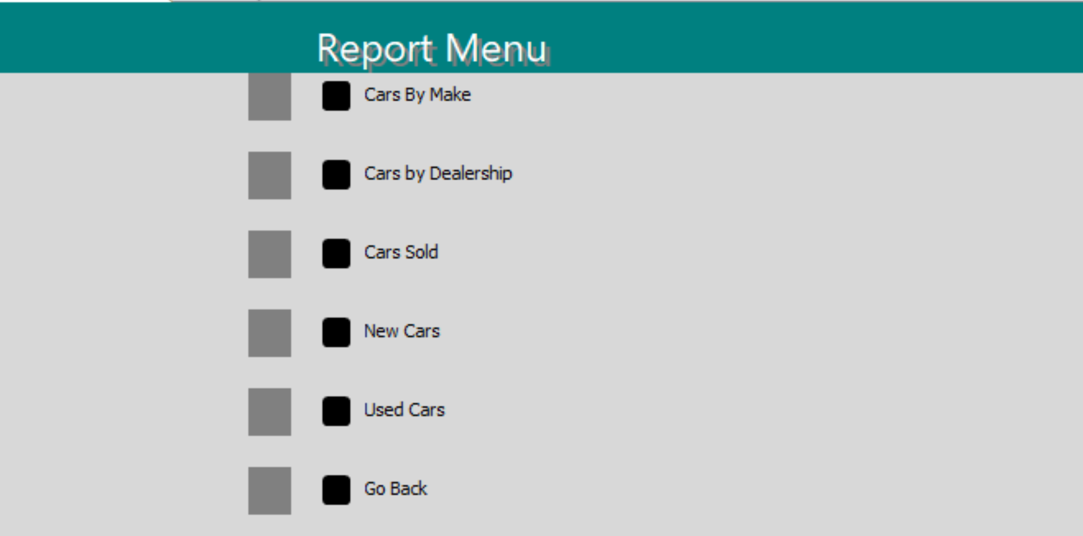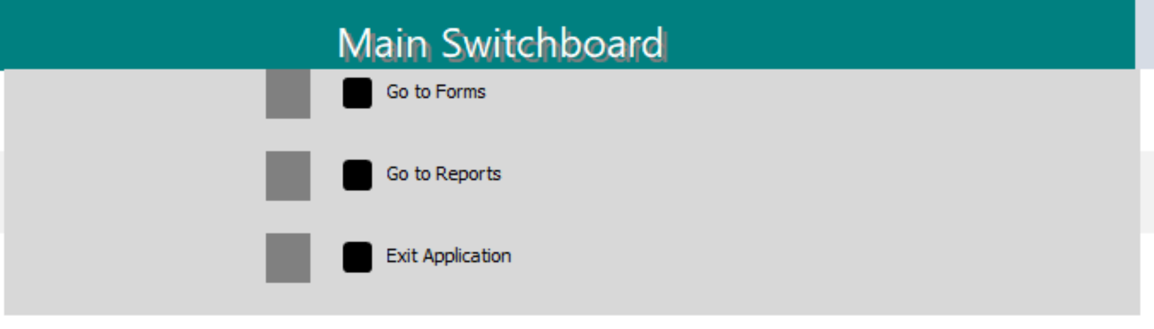

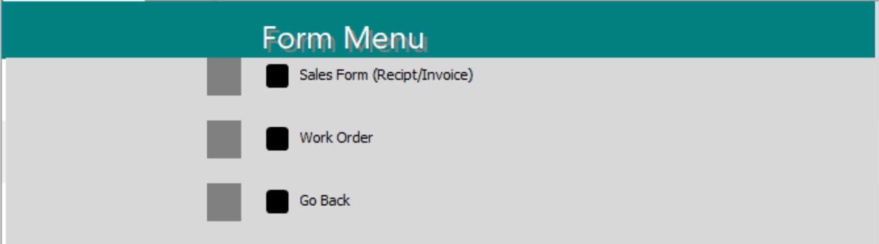

Allows the user to access reports and forms without having to view all of the data.

**Work Order Form**

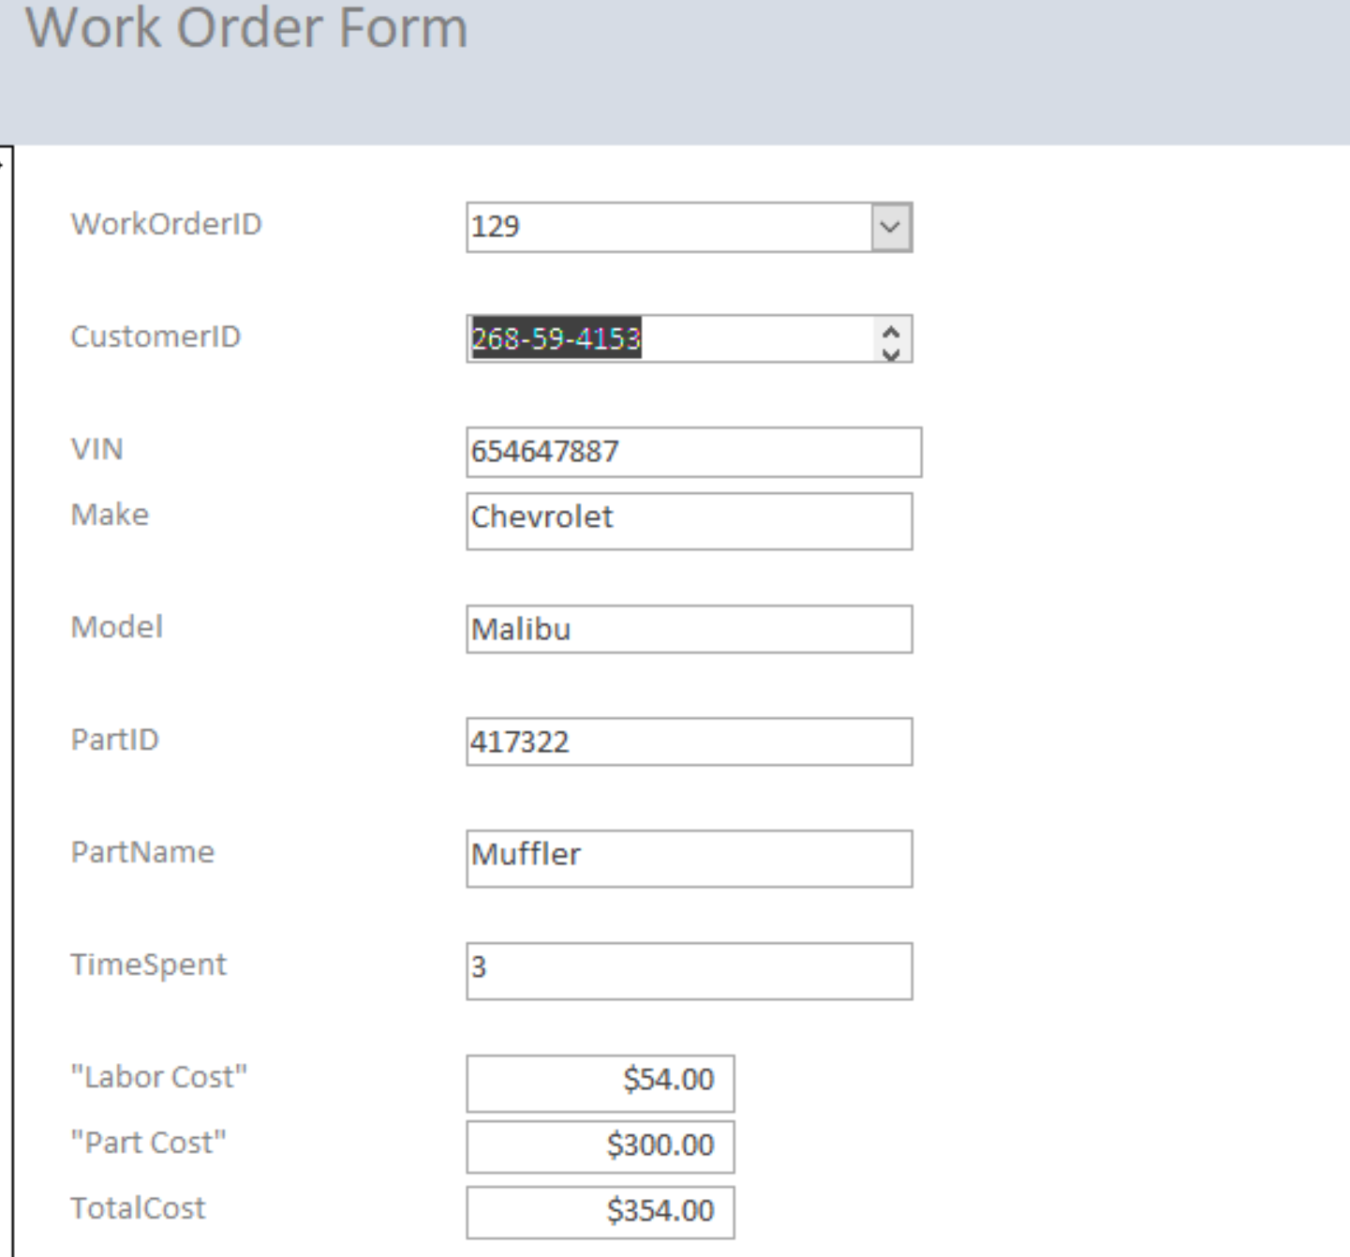

Enters work orders into the database and includes car, customer, work done and total cost.

**Reports**

**Cars by Dealership**

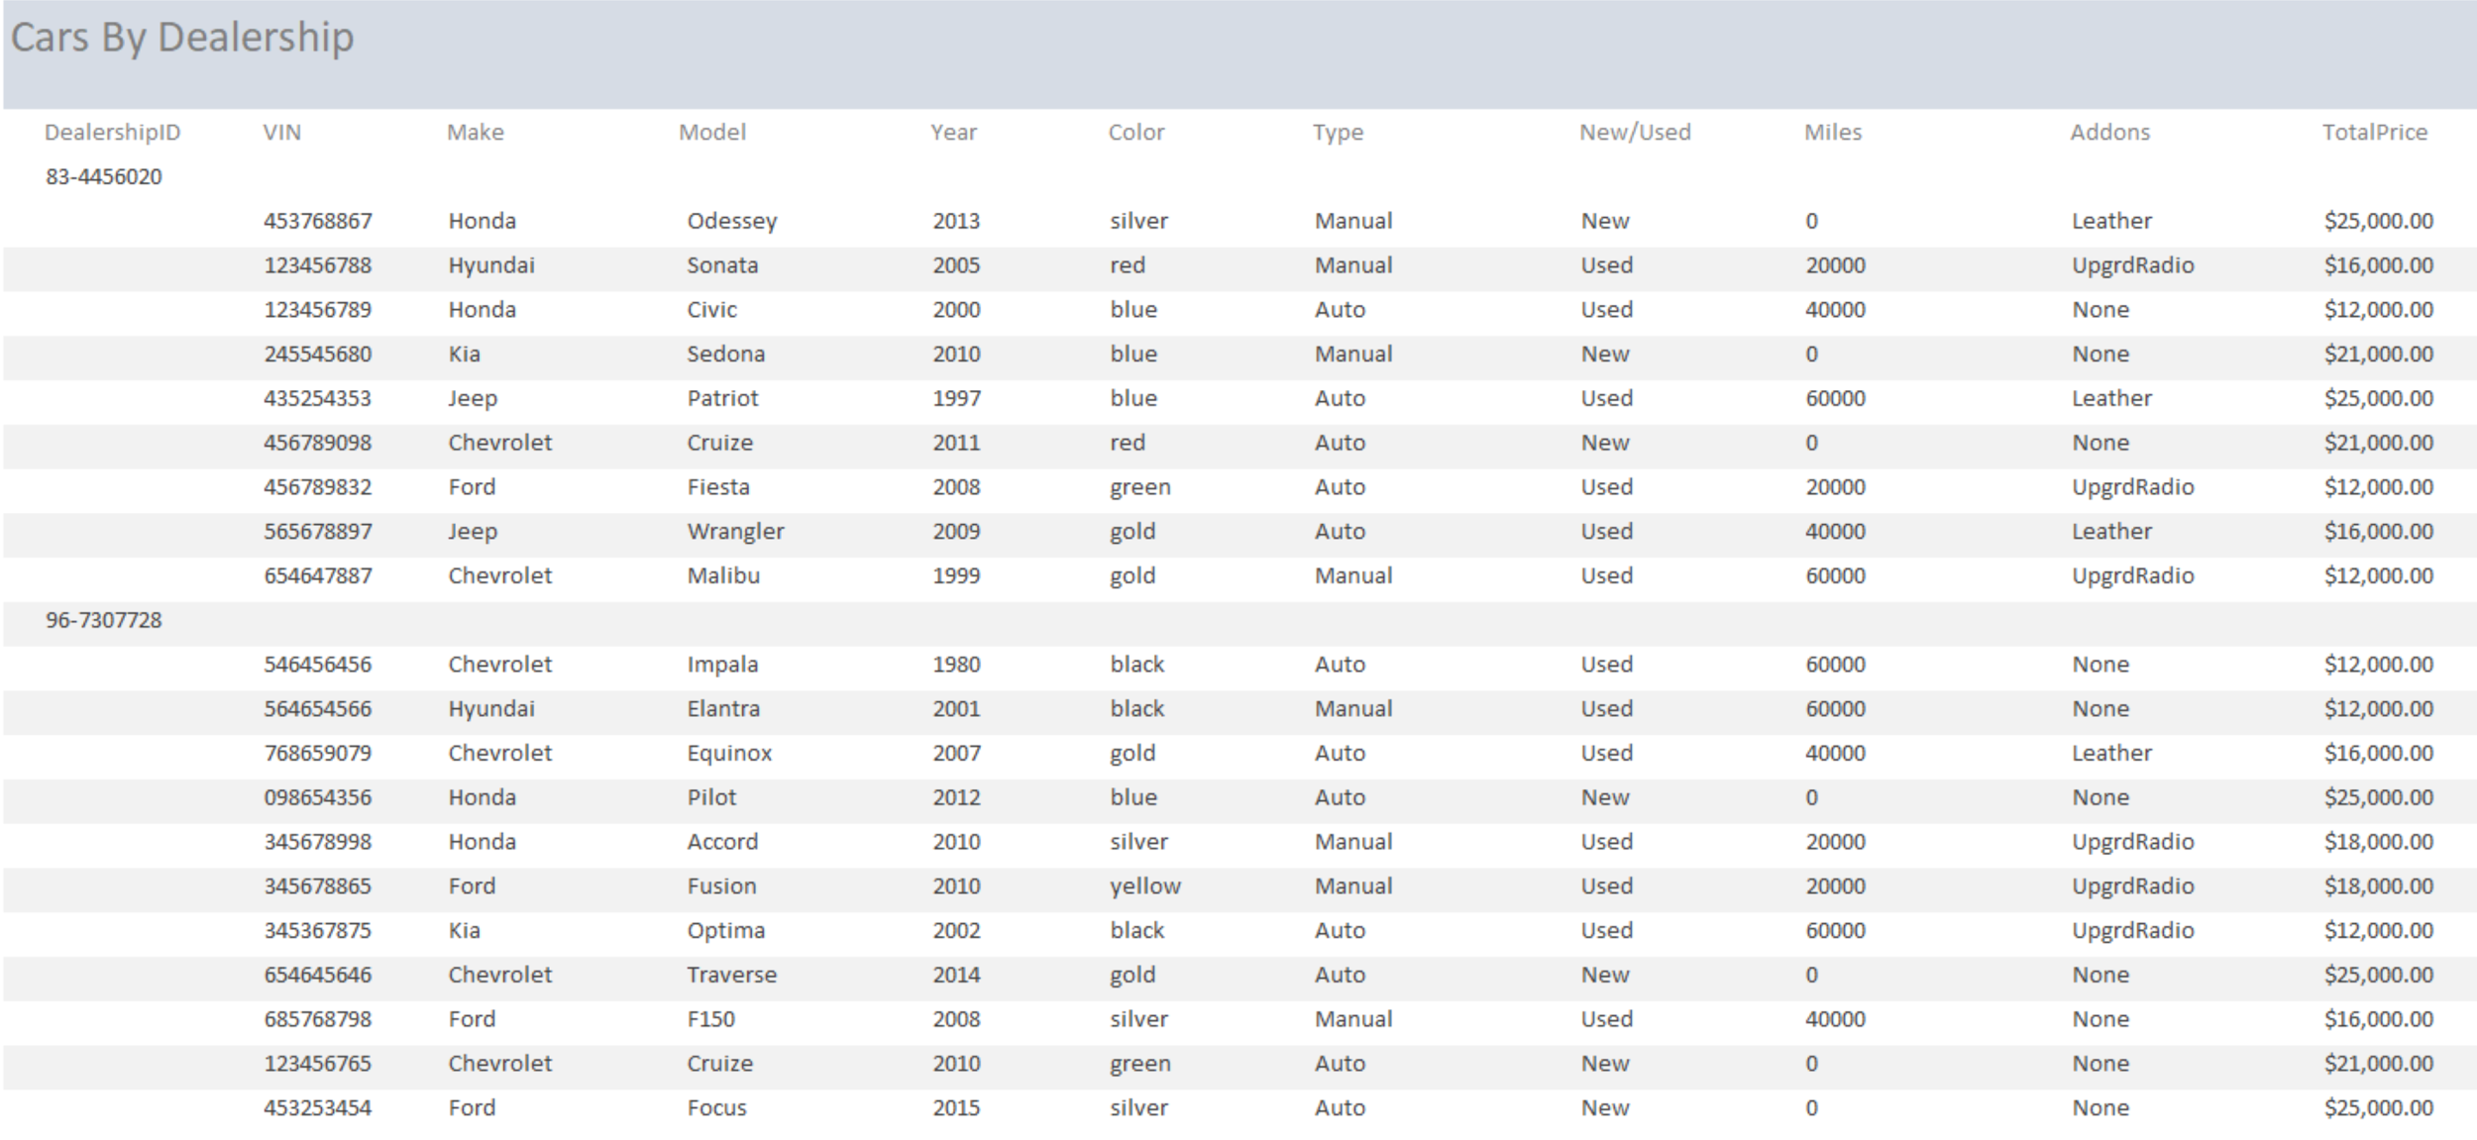

Shows complete list of cars at each dealership.

**Cars by Make**

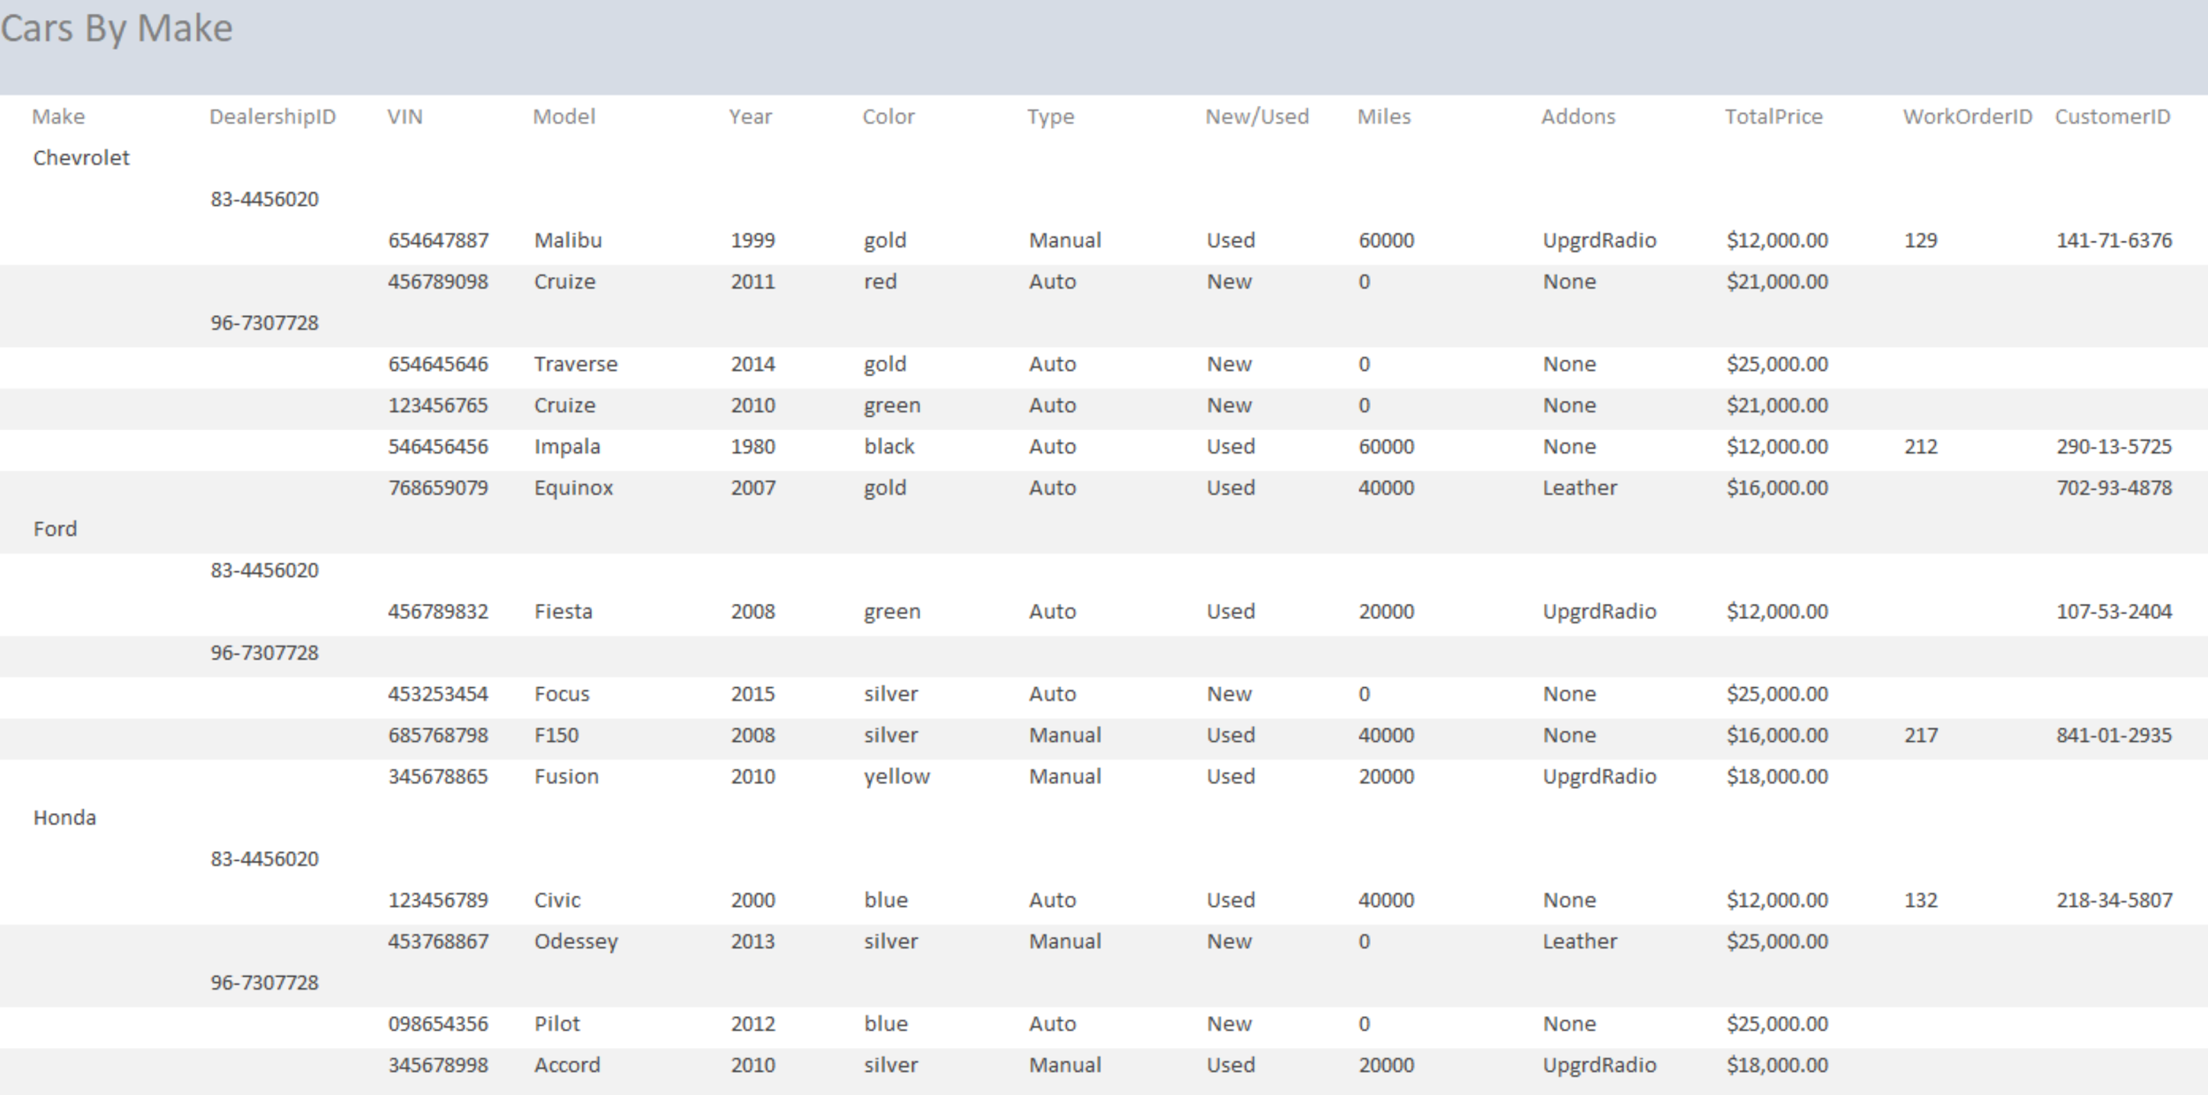

Lists all cars based by their make. Makes it easier for car buyers to search for cars in inventory if they want a certain make.

**New Cars Report**

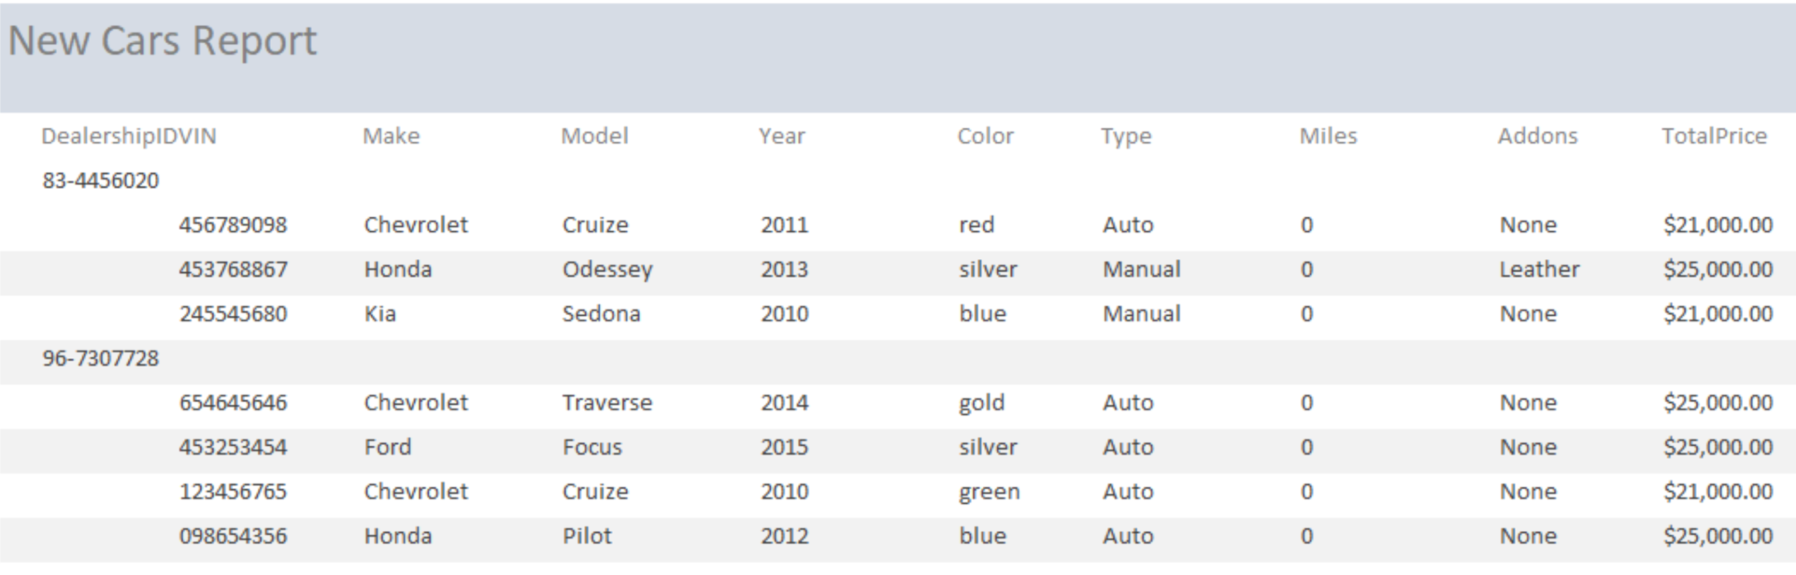

Shows all cars that are new, separated by dealership.

**Sold Cars Report**

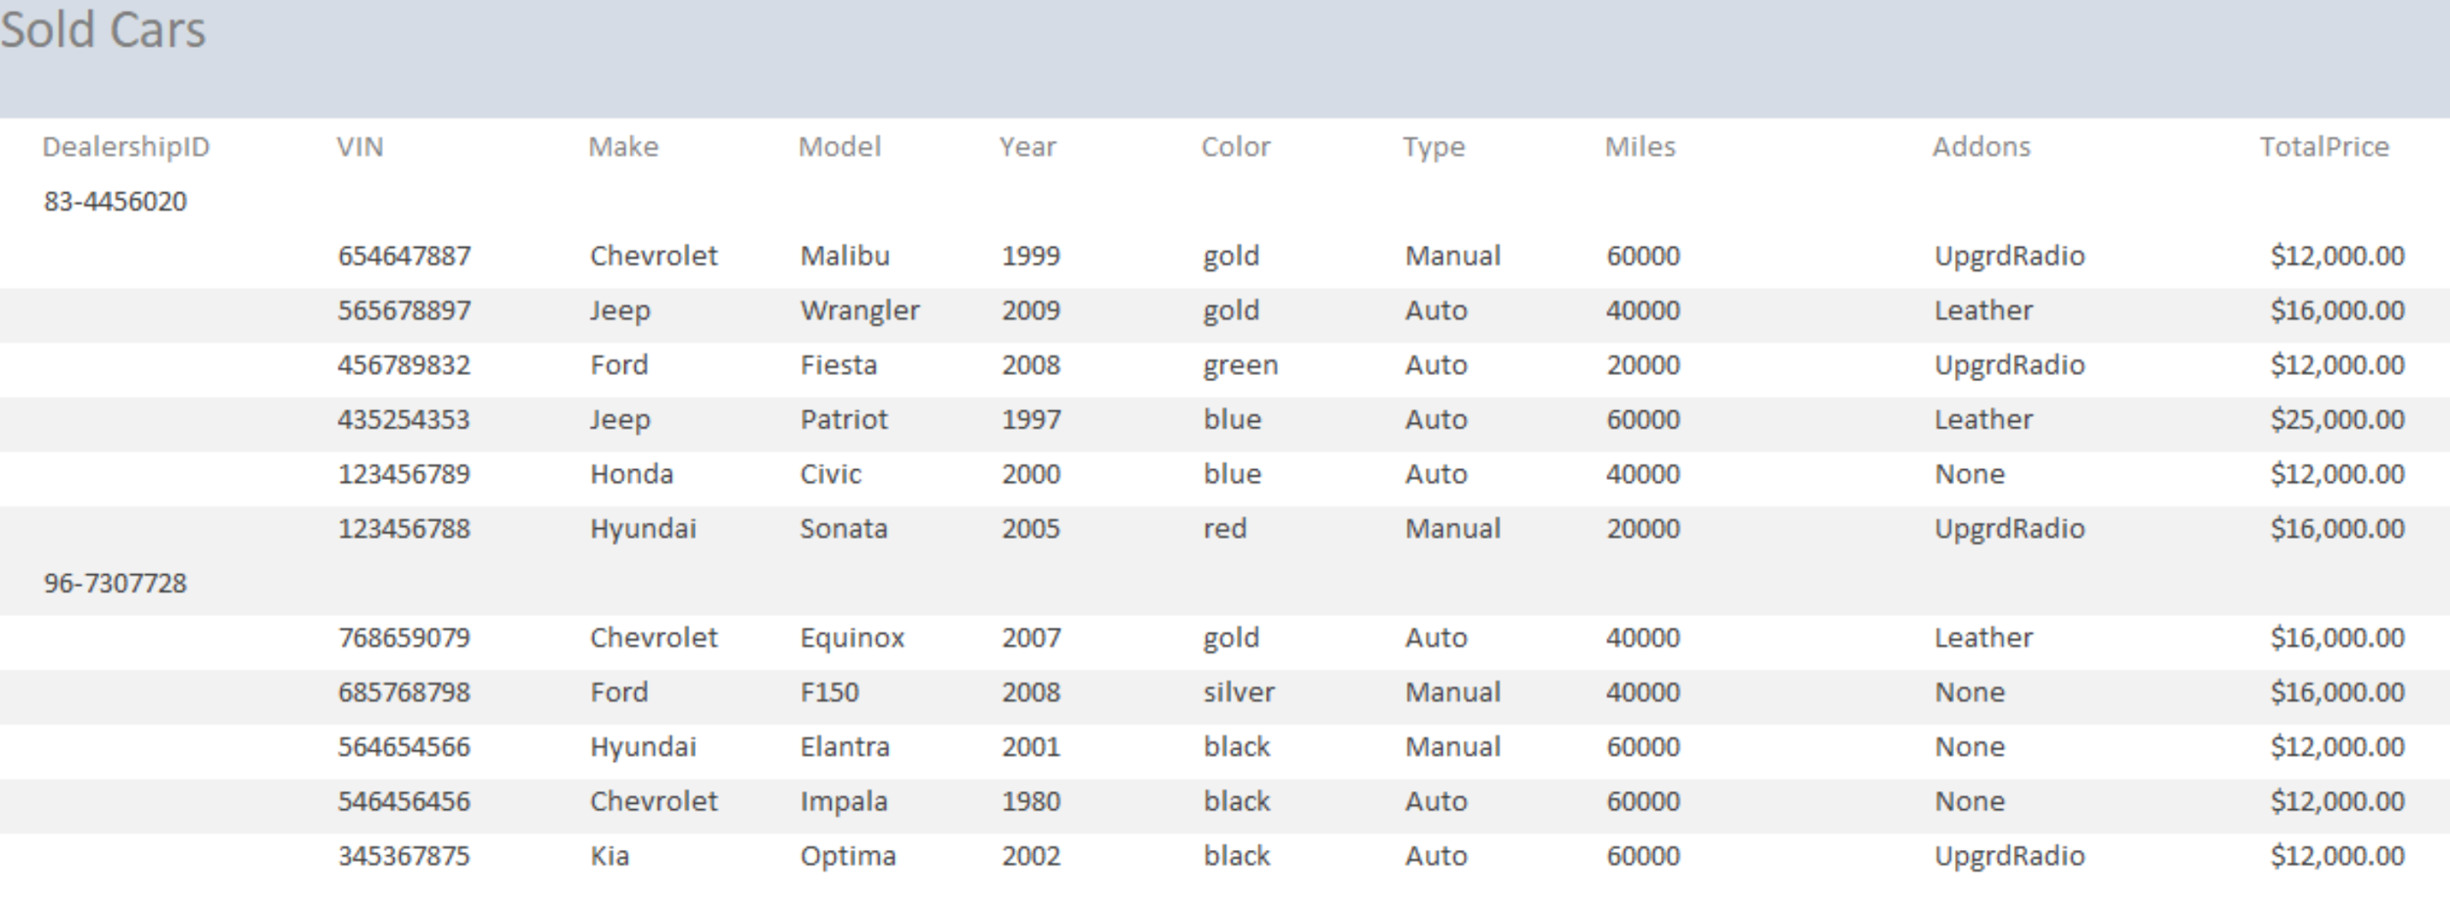

Shows all cars that have been sold, separated by dealership.

**Used Cars Report**

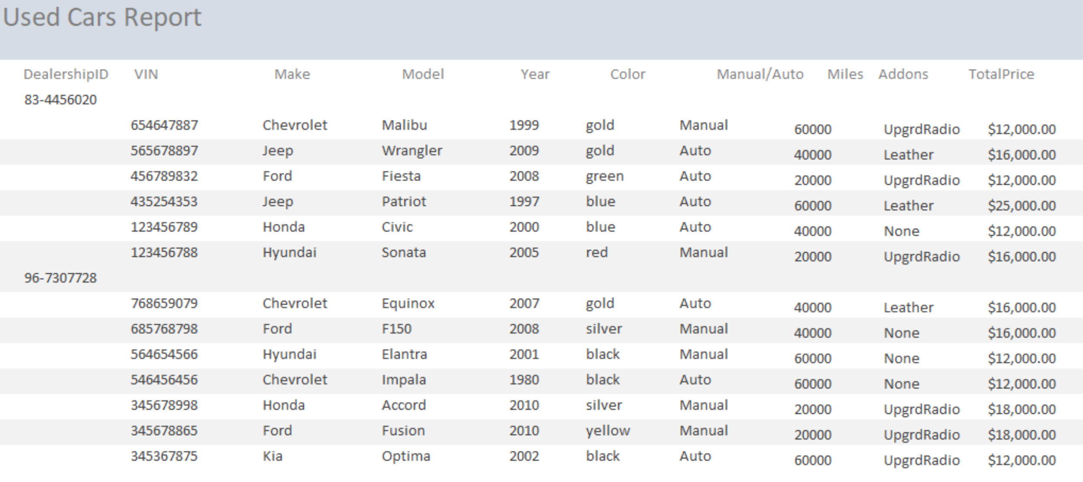

Shows all cars that are used, separated by dealership.

**What We Learned**

As a group we learned a lot during this project. The biggest thing we learned was that the database was much for extensive then we once imagined. It took a lot more work and communication to react the final product. We didn’t originally have a great grasp of bridge tables, but over time learned how to utilize them and they ended up being very important in our project. We also learned that in our ER diagram that we misuse our attributes in some instances because of how the bridge tables worked because using the same name for an attribute that wasn’t a foreign key was bad. We later switched this once we learned about the mistake. We also learned that when working with access, only one person can work on the project at a time. By this I mean there were times were a few of us wanted to all do work on the database but couldn’t simply because someone was already doing so. In this case we would have to wait for them to finish, repost the database and then start to work on what we wanted. This segways in the next big thing which was communication is extremely important. Communication is always important but we found it to be more so in this project than in previous. Lastly as a group we learned that working together is important and that no one person should have to do all the work by themselves.

**Limitation of Database and Future Work**

The database currently is limited by a lesser user friendly system than you would see in a database that has been bought from another company. The database is made for small business as well, with a few different locations in mind, it would not work well for a national or multinational enterprise, it just wouldn't have the kind of ability to have such a large quantity of data and reports. In the future we would like to expand the coverage of our database to include more than just the local area, allow it to be expanded to more locations. Also the inclusion of more options such as used car history and a description section for the work order table. The forms and reports could be more color coated and have some more user friendly features like buttons and autofill boxes.